A

Project Report

On

“**APPOINTMENT+.COM**”

Submitted to

CHHATTISGARH SWAMI VIVEKANAND TECHNICAL UNIVERSITY,

BHILAI

In partial fulfillment of requirement for the award of degree

Of

Bachelor of Engineering

In

Information Technology

By

Anima Sharma

&

Jasmeet Kaur

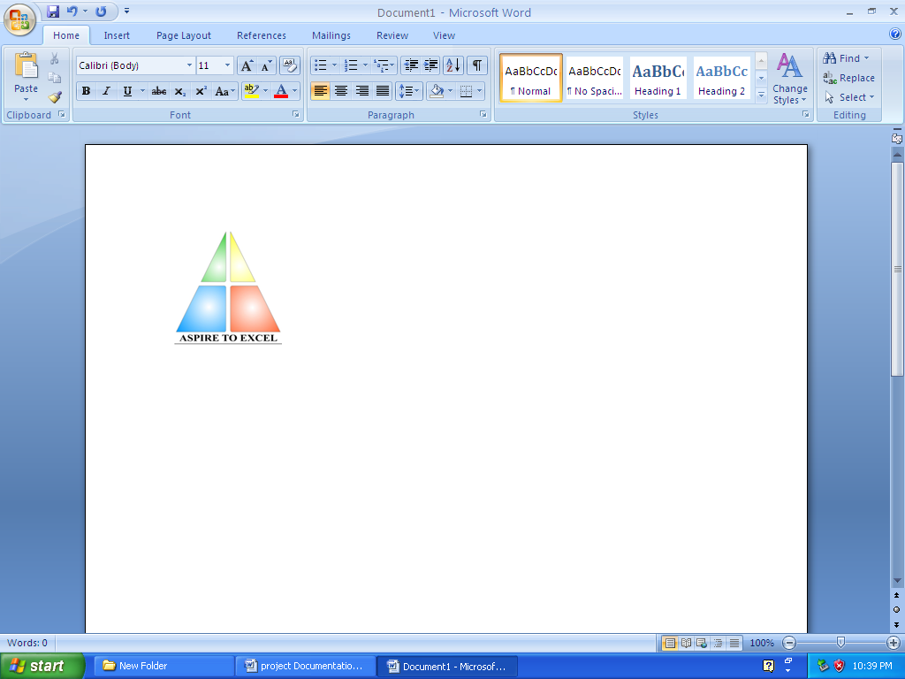

Department of Information Technology,Bhilai Institute of Technology, Bhilai House, Durg, Chattisgarh -491001.

Session: 2006-2010

**DECLARATION**

I the undersigned solemnly declare that the report of the project work entitled

***Appointment+.com*** is based on my own work carried out during the course of my study under the supervision of *Mr. Rajkumar Singh.*

I assert that the statements made and conclusions drawn are an outcome of my research work. I further declare that to the best of my knowledge and belief the report does not contain any part of any work which has been submitted for the award of any other degree/diploma/certificate in this University or any other University of India.

(Signature of the Candidate)

Name of the Candidate : Anima Sharma

Roll No. : 3013306007

Enrollment No. : AA9810

(Signature of the Candidate)

Name of the Candidate :Jasmeet Kaur

Roll No. : 3013306016

Enrollment No. : AA9839

Signature Of Supervisor

Mr.Rajkumar Singh

(Lecturer)

Information Technology

B.I.T. , Durg(C.G.)

**CERTIFICATE**

This is to certify that the report of the project submitted is an outcome of the project work entitled “**APPOINTMENT+.COM**” carried out by

|  |  |  |  |
| --- | --- | --- | --- |
| SNO | NAME OF STUDENT | ROLL NO | ENROLLMENT NO |
| 1. | ANIMA SHARMA | 3013306007 | AA9810 |
| 2. | JASMEET KAUR | 3013306016 | AA9839 |

Carried out under my guidance and supervision for the award of Degree in Bachelor Of Engineering in Information Technology of Chhattisgarh Swami Vivekanand University , Bhilai (C.G) , India .

To the best of my knowledge the report

1. Embodies the work of the candidate him/herself ,
2. has duly been completed,
3. Fulfils the requirement of the Ordinance relating to the B.E. degree of the University and
4. Is up to the desired standard for the purpose of which is submitted.

____________________

(Signature of the Guide) Name of Guide : Mr. Rajkumar Singh Designation : Lecturer Department : I.T. Institute : B.I.T., DURG

The project work as mentioned above is hereby being recommended and forwarded for examination and evaluation.

(Signature of HOD with seal ) _______________________________

Forwarded to Chhattisgarh Swami Vivekanand Technical University, Bhilai

( Signature of Director/Principal )

Bhilai Institute Of Technology , Bhilai House Durg-491001 ,CHHATTISGARH , INDIA

**CERTIFICATE BY THE EXAMINERS**

This is to certify that the project work entitled

“**APPOINTMENT+.COM**”

Submitted by

|  |  |  |  |
| --- | --- | --- | --- |
| **SNO** | NAME OF STUDENT | ROLL NO | ENROLLMENT NO |
| 1. | ANIMA SHARMA | 3013306007 | AA9810 |
| 2. | JASMEET KAUR | 3013306016 | AA9839 |

has been examined by the undersigned as a part of the examination for the award of Bachelors of Engineering degree in Information Technology of Chhattisgarh Swami Vivekanand University , Bhilai (C.G) .

___________________ ___________________

Internal Examiner External Examiner

Date: Date:

**ACKNOWLEDGEMENT**

Working on this project has been a great learning experience for us. There were moments of anxiety, when we could not solve a problem for several days and there were moments when we could solve a problem after struggling for several days. But we have enjoyed every bit of the process and are thankful to all people associated with us during this period.

We convey our sincere thanks to our project guide *Mr.Rajkumar Singh,* for providing us all sorts of facility. His support and guidance helped us to carry out the project. I owe a great debt of his gratitude for his constant advice, support, co-operation and encouragement throughout the project.

We would like to express our deep gratitude to respected H.O.D Information Technology Department *Mrs. Arpana Rawal* madam for her helpful solutions and comments enriched by experience, which improved our ideas for betterment of project.

It will be our pleasure to acknowledge, utmost co-operation and valuable suggestion from time to time given by *Mr. Amrendra Singh (Project In-Charge)* and also we would like to thank all those persons who have directly or indirectly helped us by providing books and computer peripherals, and other necessary amenities which helped in the. development of this project which would otherwise have not been possible.

**_______ ________**

(Anima Sharma) (Jasmeet Kaur)

Information Technology, 8th Semester

Bhilai Institute of Technology, Bhilai House, Durg, Chattlsgarh-491001

**TABLE OF CONTENTS**

1. Introduction ……………………………………………………………………………....8
2. Literature Review ………………………………………………………………………..10
3. Problem Identification …………………………………………………………………...19
   1. Current System ……………………………………………………………………...19
   2. Solution Strategy ………………………………………………………………….....19
   3. Feasibility Study …………………………………………………………………….19
   4. Programming Team Structure ……………………………………………………....20
4. Methodology……………………………………………………………………………...24
   1. Hardware Requirements……………………………………………………………..24
   2. Software Requirements………………………………………………………………24
   3. Technology Used…………………………………………………………………….25
   4. Life Cycle Model…………………………………………………………………….25
   5. Architectural Design…………………………………………………………………27
   6. Work Flow Diagram…………………………………………………………………31
5. Implementation……………………………………………………………………………33

5.1Client Module …………………………………………………………………………33

5.2 Organization Module.………………………………………………………………....45

5.3Common Module………………………………………………………………………55

5.4Administrator Module………………………………………………………………….57

1. Testing……………………………………………………………………………………..59

6.1 Testing Approach..…………………………………………………………………….59

1. Conclusion & Future scope………………………………………………………………..62

7.1 Conclusion……………………………………………………………………………..62

7.2 Future Scope……………………………………………………………………………62

1. Bibliography and References................................................................................................64

**INTRODUCTION**

**1.INTRODUCTION**

Our project aims at helping clients to get an organization’s details and maintain their appointments with the respective organization and to facilitate organizations to manage their own clients. It allows the users to create or modify appointments online. It is a single website which keeps records of various organizations appointment schedules and manage them in appropriate manner. It provides facilities for taking new appointments, rescheduling existing appointments or deleting unnecessary appointments.

The databases of information are maintained in an appropriate manner so as to enable the retrieval and entering of the information.

The site also fulfills the following objectives:

1. To provide the information about various organizations.
2. To provide the organizations the fascility of updating their records.
3. To provide information about specialists whose appointment is to be taken.
4. To provide the organization the information about its clients by creating accounts.

**LITERATURE**

**REVIEW**

**2. LITERATURE REVIEW**

While taking appointments the users are bound to visit the organisation personally or make it through telephone. This is time wasting and inconvenient for persons who are not able to visit the organisation each time they need to fix an appointment with an specialist.

Also while taking appointment we must be sure about the validity and efficiency of organisation and any other preferences(if exists).Collecting all this information is a tedious task and sometimes the sources of information are also not reliable.

We are making this project for all the people who want to know about the particular organization and the specialist. For people who are not able to visit the place each time they need an appointment. We are providing the information about various specialists and also provides relevant details about organizations.

**2.1 Web Design Process**

Designing a web site is a process consisting of six phases:

**.:.** Project Definition

**.:.** Visual Design

**.:.** Site Development

**.:.** Testing

**.:.** Launch

**.:.** Maintenance

* + 1. **Project Definition**

The most critical step in the web design process is creating an accurate project definition. A project definition includes a project brief and a project plan. The client survey is used to gather the information needed to develop the project brief and plan.

How do you create the project definition?

Step 1: **Conduct a Client Survey Interview** - The purpose of this interview is to determine the purpose of the project, the target audience, branding/perception goals, content source, technical specs and communication strategy. Use this client survey to guide your interview.

Step 2: **Write the Project Brief/Creative Brief** - Based on the information gathered in the client survey, write the project brief to define in black and white the project goals, audience profile, audience perception, primary message and competitive advantage. Here is a sample project brief.

Step 3: **Write the Project Technical Specifications** -Using the information gathered in the client survey along with the technical standards of your organization, document the Technical Specifications to clearly establish requirements like screen resolution, browser compatibility, download time, web standards and accessibility. Here is a sample technical specification.

Step 4: **Develop the Project Plan Timeline** - Establish the timeline for deliverables and tasks for each phase of the project. Assign due dates and resources.

Step 5: **Document Maintenance Considerations** -Develop a web site maintenance plan that documents how the site will be updated and reviewed regularly.

* + 1. **Visual Design**

*"Structuring the site on paper before starting visual design is a critical step toward effective presentation of content toy our intended audience."*

*"Designers are not mind readers or magicians. Good design is dependent on good site structure and a solid project definition."*

The designer(s) should also review any branding guidelines as well as the technical requirements for screen resolution, browser compatibility, download time, web standards and accessibility.

At this point, the designer(s) has a clear idea of the purpose of the site, the content that will comprise the site, the site architecture and the elements that need to be on each page.

Drawing on their knowledge of design principles (balance, rhythm, proportion, and dominance), design elements (point, line, shape, color, typography) and user centered design (usability); they can develop design options that meet the project goals.

A sample of the visual design tasks:

1. 1st draft of visual designs for home page and one sub-page.
2. Client provides feedback on designs.
3. 2nd draft of visual designs for home page and one sub-page.
4. Client selects design and provides feedback.
5. 3rd draft of visual design for home page and all unique sub-pages.
6. Client provides feedback on design.
7. Final visual designs for home page and all unique sub-pages Client approval of final design.
   * 1. **Site Development**

Now it is time to actually build the site. There are two major steps during this stage:

---Technical/Functional Plan

---Build and Integrate the Site

* + - 1. **Technical/Functional Plan-**

Start by reviewing the Project Brief, Site Structure and Visual Design and confirm that everything is in alignment and supports the overall project goals and needs. Next, set the technical/functional specifications for the site:

* ***Target Technical Specs***- what browsers, as, resolution and connection speeds will you target.

**Browsers\*** - what browsers will you target?

**Operating System\*** -MAC, Windows, Others?

**Display Resolution\*** -what is the screen resolution the site will be designed for? What other screen resolutions will be supported gracefully?

**Connection Speed\*** - what is expected connection speed for your primary users, what other connection speeds will you target?

* ***Functional Specs***- what functionality does your site require? Use of W3C web standards is recommended to insure that your site pursues the goals of web for everyone and web on everything.
* ***Project Plan***- review your original timeline and the technical and functional specs you've just established. Do you have the resources you need to complete the project on time and within budget? Refine and add details to the project plan you drafted during the Project Definition Stage. Your project plan should now include a detailed list of concrete tasks, assignments, target dates and dependencies between tasks.
  + - 1. **Build and Integrate the Site**

To turn all this planning into reality! The steps include:

* **Build templates using web standards**:
* CSS -separate presentation from content
* (X)HTML-use valid (X)HTML
* JavaScript-add scripting, make sure to maintain accessibility
* Optimize -optimize images, CSS and (x) html
* Run initial tests on templates
* **Create Pages**:
* Pour content into templates.
* Establish method for content contributors to review, update and add content.
* **Backend Development:**

Code dynamic features of the site that require database/ CGI and integration like:

* Search
* Personalization/login
* Secure transactions
* Web analytics
  + 1. **Testing**

Your original project plan should always allocate time for formal testing. Ideally, you should identify a person to serve as the Quality Assurance Lead. This individual's priority will be to create a realistic QA plan, manage the testing process, prioritize issues, insure that high priority issues are solved and conduct the final review and release of the project.

**2.1.4.1 Quality Assurance Testing**

1. Content - accurate, understandable, spelling, grammar (review conducted by content contributors / content editors).
2. Links - review site for broken links Functionality -does the site perform the functions defined in the original project definition, create task list and conduct methodical testing.
3. Validity -validate (X)HTML, validate CSS.
4. Browser/OS/Resolution - test site on the target browsers your defined earlier either manually or using browser cam.
5. Connection Speed - use the Web Page Analyzer to get analysis and recommendations on the speed/size of your pages.
6. Usability-conduct informal or formal usability testing with your target audience.
7. Load Testing - contact your server administrator to discuss load testing techniques.
8. Security-request automated Security Scan, review file authorizations, etc.

**2.1.4.2 Prioritize Issues**

Taking the time to conduct testing prior to production is an important element in launching a high quality site. However, if you wait until the site is perfect, you will never launch.

There is a balance between perfection and realistic quality that must be struck. As you monitor the list of issues that are uncovered during the testing phase, prioritizing them in at least three categories:

Priority 1 - critical, must be fixed before launch.

Priority 2 - would enhance the site, but we can go live without it, address as soon as time permits.

Priority 3 -future enhancement, nice idea/feature, will consider for future release.

* + 1. **Launch**

As the site gets ready to go production, it is important to document the style guide. A style guide consists of the following elements:

* **Visual Design Standards**- logos, colors, typography(to keep the site on brand).
* **Naming Conventions**- for files, directories, CSS, images, titles.
* **Site Structure**- document the site diagram and indicate how the structure is built to handle growth.
* **Templates**- provide the (X) HTML templates and CSS indicating layout, typography, size, color, navigation, menus.

If possible, consider a soft launch (a quiet beta launch that allows you to confirm everything is up and running before the official launch date).

* + 1. **Maintenance**

Implement the maintenance plan that was developed in the first stage of this process. Emphasize the importance of keeping a project:

* Complete
* Current
* Coherent
* Accessible
* Attractive
* Robust
* Secure
* Cost Effective
* Aligned with the spirit and goals of the project

**PROBLEM IDENTIFICATION**

**PROBLEM IDENTIFICATION**

**3.1 CURRENT SYSTEM:**

The information about various organizations and specialists is only available in the printed media and the information is provided via the mass media are basically the advertisements which are very less in number and also does not provide the actual information. So, the best one could do is to get the information from friends, relatives, newspapers and television sometimes these sources are not reliable since they are only advertisements or personal experience of other people.

Also the various phases that are to be faced before confirming any appointment are tedious and time wasting. The organizations were also not able to provide their updated information to the clients.

.

**3.2 PROJECT SOLUTION STRATEGY:**

On completion of the project our website will be able to be provide all the information related to organizations and specialists and the user will just need an internet connection through which he/she can easily log on to APPOINTMENT+.COM and get the desired information and fix an appointment.

**Beneficiaries of the project:**

* Clients seeking for appointments
* Organizations willing to provide appointments

**3.3 FEASIBILITY STUDY**

It is very important to do preliminary investigations regarding the development of the system to ensure its possible usefulness for the organizations.

Thus before developing a system, it is necessary to test the feasibility of the project.

There are five aspects to be covered for testing project feasibility:

**3.3.1 Technical Feasibility**: The development of a system is technically feasible as the various technological needs for the development & deployment are fulfilled. The system is to be developed using familiar software & hardware tools (PC, Hard Disk, Java 1.6, and Web browser).

**3.3.2 Operational Feasibility**: This feasibility depends much on the willingness of the users to accept the system replacing their manual or old systems. As the users propose this system, its operation is much feasible .The only thing is that the users of the proposed system should be trained for using the system. The willingness to learn the new system developed makes the system much more feasible.

**3.3.3 Implementation Feasibility**: The organization has all the facilities required for developing the system. All software's required for the developments of the system are provided by the organizations & has got the necessary infrastructure, which makes the project feasible in implementing.

**3.3.4 Schedule Feasibility**: University allocates the time of weeks for the project, which seems to be enough for the development of the system as per the requirements put forward by the organizations. So, we can say that the project is feasible in terms of schedule.

**3.3.5 Economic Feasibility**: Since all the above mentioned feasibility tests are passed for the carrying out of the project. The feasibility was not the problem for such a large organization.

**3.4 PROGRAMMING TEAM STRUCTURE:**

The project has employed the Democratic Decentralized Team Structure. Individuals were responsible for coordinating team-activities regarding the project work. All the team members have possess equal expertise thereby making the decision making process is collective.

In this project team, no pattern of hierarchy has been followed. Both team members are free to communicate her views/opinions directly to other member, she wishes. Although work-division was equal and needed individual attention, team mutually co-ordinated at times of difficulty and was guided rightly by the project incharge.

*Fig 3.1 The Democratic Decentralized Team Structure.*

**METHODOLOGY**

**METHODOLOGY**

**4.1** **HARDWARE REQUIREMENTS**

The hardware requirements of our project are as follows:

Processor - Pentium 3 or above

Mother Board -Intel 810 or above

VDU Resolution -SVGA supporting at least 800X 600

RAM -256 MB or above

Hard Disk -40GBor above

Monitor -Monochrome or colored

Printer -Laser or any other

Keyboard & Mouse -Any compatible with above configuration

**4.2 SOFTWARE REQUIREMENTS**

Here are the software requirements of our project:

**4.2.1 OPERATING SYSTEM** - Microsoft Windows XP.

**4.2.2 WEB BROWSER** -Mozilla Firefox/Internet Explorer4.3

**4.2.3 Software Requirements Specification**

The software Requirement Specification is produced at the culmination of the analysis task. The function and performance allocated to software as part of system engineering are refined by establishing a complete information description, a detailed functional description, a representation of system behavior, an indication of performance requirements and design constraints, appropriate validation criteria, and other information pertinent to requirements.

The Introduction of the software requirements specification states the goals and objectives of the software, describing it in the content of the computer-based system. Actually, the Introduction may be nothing more than the software scope of the planning document.

The Information Description provides a detailed description of the problem that the software must solve. Information content, flow, and structure are documented. Hardware, software, and human interfaces are described for external system elements and internal functions.

The following block diagram shows the interaction took place between the different phases. This in turn gives the information about the SRS.

User or client

Problem Description

SRS

Verification

Problem Analysis

Fig4.1: **Requirement Process**

A description of each function required to solve the problem is presented in the Functional Description. A processing narrative is provided for each function, design constraints are stated and justified, performance characteristics are stated, one or more diagrams are included to graphically represent the overall structure of the software and interplay among software functions and other system elements.

The Behavioral Description section of the specification examines the operation of the software as a consequence of external events and internally generated control characteristics.

Validation Criteria is probably the most important and, ironically, the most often neglected section of the Software Requirements Specification.

* How do we recognize a successful implementation/
* What classes of tests must be conducted to validate function, performance, and constraints?

We neglect this section because completing it demands a thorough understanding of software requirements/something that we often do not have at this stage. Yet, a specification of validation criterion acts as an implicit review of all other requirements. It is essential that time and attention be given to this section.

All the phases of the requirement process well fulfill the operational principles of requirement specification over the software requirements mentioned above. Thus the software requirement specifications are well developed.

**4.3 TECHNOLOGY USED**

*(Technological Requirements for project development)*

4.3.1 FORNTEND-JSP(J2EE PLATFORM)

**JavaServer Pages** (**JSP**) is a [Java](http://en.wikipedia.org/wiki/Java_(programming_language)) technology that helps [software developers](http://en.wikipedia.org/wiki/Software_developer) serve [dynamically generated web pages](http://en.wikipedia.org/wiki/Dynamic_web_page) based on [HTML](http://en.wikipedia.org/wiki/HTML), [XML](http://en.wikipedia.org/wiki/XML), or other document types.

JSP was designed to address the perception that the Java programming environment didn't provide developers with enough support for the Web.

Architecturally, JSP may be viewed as a high-level abstraction of [Java servlets](http://en.wikipedia.org/wiki/Java_servlet). JSP pages are loaded in the server and operated from a structured special installed Java server packet called a Java EE Web Application, often packaged as a .war or .ear file archive.

JSP allows Java code and certain pre-defined actions to be interleaved with static web markup content, with the resulting page being compiled and executed on the server to deliver an HTML or XML document. The compiled pages and any dependent Java libraries use Java bytecode rather than a native software format, and must therefore be executed within a [Java virtual machine](http://en.wikipedia.org/wiki/Java_virtual_machine) (JVM) that integrates with the host [operating system](http://en.wikipedia.org/wiki/Operating_system) to provide an abstract platform-neutral environment.

JSP syntax is a fluid mix of two basic content forms: *scriptlet elements* and *markup*. Markup is typically standard HTML or XML, while scriptlet elements are delimited blocks of Java code which may be intermixed with the markup. When the page is requested the Java code is executed and its output is added, in situ, with the surrounding markup to create the final page. Because Java is a compiled language, not a scripting language, JSP pages must be compiled to Java bytecode classes before they can be executed, but such compilation generally only occurs once each time a change to the source JSP file occurs.

The JSP syntax adds additional [XML](http://en.wikipedia.org/wiki/XML)-like tags, called JSP actions, to invoke built-in functionality. Additionally, the technology allows for the creation of JSP tag libraries that act as extensions to the standard HTML or XML tags. JVM operated Tag libraries provide a [platform independent](http://en.wikipedia.org/wiki/Platform_independent) way of extending the capabilities of a [web server](http://en.wikipedia.org/wiki/Web_server). Note that not all company makes of Java servers are Java EE specification compliant.

JSPs are compiled into [servlets](http://en.wikipedia.org/wiki/Java_Servlet) by a [JSP compiler](http://en.wikipedia.org/wiki/JSP_compiler). The compiler either generates a servlet in Java code that is then compiled by the Java compiler, or it may compile the servlet to [byte code](http://en.wikipedia.org/wiki/Byte_code) which is directly executable. JSPs can also be [interpreted](http://en.wikipedia.org/wiki/JSP_Weaver) on-the-fly, reducing the time taken to reload changes.

4.3.2 BACKEND-MYSQL DB

A database is a structure that comes in two flavors: a flat database and a relational database. A relational database is much more oriented to the human mind and is often preferred over the gabble-de-gook flat databases that are just stored on hard drives like a text file. MYSQL is a relational database.

In a relational structured database there are tables that store data. The columns define which kinds of information will be stored in the table. An individual column must be created for each type of data you wish to store.

Databases are most useful when it comes to storing information that fits into logical categories. For example, say that you wanted to store information of all the employees in a company. With a database you can group different parts of your business into separate tables to help store your information logically. Example tables might be: Employees, Supervisors, and Customers. Each table would then contain columns specific to these three areas.

MYSQL is currently the most popular open source database server in existence. On top of that, it is very commonly used in conjunction with PHP scripts to create powerful and dynamic server-side applications.

**4.4 LIFE CYCLE MODEL**

To solve actual problems in an industry setting, a software engineer or a team engineer must incorporate a development strategy that encompasses the process, methods, and tools layers described follows and the generic phases discussed in the figure below. This strategy is often referred to as a process model or a software engineer paradigm. A process model for software engineering is chosen based on the nature of the project and application, the methods and tools to be used, and the controls and deliverables that are required. In an intriguing paper on the nature of the software process uses fractals as the basis for a discussion of the true nature of the software process

Fig.4.2 Prototype **Model**

Technical

Development

Solution

Integration

Problem

Definition

All software development can be characterized as a problem solving loop (Fig) in which four distinct stages are encountered: status quo, problem definition technical development, and solution integration.

Status quo ‘represents the current state of affairs problem definition identifies the specific problem to be solved, technical development solves the problem through the application of some technology delivers the results (e.g. documents, programs, data, new business function, new product) to those who requested the solution in the first place.

The generic software engineering phases and steps defined easily defined map into these stages. As in the above figure we can categories the problem solving in the following steps:

1. Status quo
2. Problem definition
3. Technical Development
4. Solution Integration

4.5 **ARCHITECTURAL DESIGN**

The Architectural design of a software project involves:

* Identifying the software components.
* Decoupling & decomposing the software components into modules & conceptual data structures.
* Specifying the interconnections between the various components.

**4.5.1 DATABASE TABLES**

**4.5.1.1 CUSTINFO TABLE**

|  |  |
| --- | --- |
| **COLUMN NAME** | **DATA TYPE** |
| Sno | Integer(autoincrement) |
| Cmail | Varchar(145) |
| Cpwd | Varchar(45) |
| Cname | Varchar(45) |
| cDOB | Date |
| Cpadd | Varchar(145) |
| Ctadd | Varchar(145) |
| Csex | Varchar |
| cCon | Varchar(45) |
| Cdesg | Varchar(45) |
| corg | Varchar(45) |

The table contains all the necessary information related to the clients of all the organizations . These clients take appointments to the specialists.

**4.5.1.2 INBOX TABLE**

|  |  |
| --- | --- |
| **COLUMN NAME** | **DATATYPE** |
| Sno | Autonumber |
| Message | Varchar(145) |
| Sender | Varchar(145) |
| Receiver | Varchar(145) |
| Sent_time | Varchar(45) |
| appnum | Int(12) |

This table contains all messages sent as confirmation of the appointment fixing to the clients and the corresponding specialists.

**4.5.1.3 ORGANISATION TABLE**

|  |  |
| --- | --- |
| **VARIABLE NAME** | **DATA TYPE** |
| Sno | Autonumber |
| oEmail | Varchar(145) |
| orgPwd | Varchar(45) |
| orgName | Varchar(145) |
| No_of_slot | Int(12) |
| Work_slots | Varchar(145) |
| Work_days | Varchar(145) |
| staffCap | Int(12) |
| Loc | Varchar(145) |
| catagory | Varchar(60) |
| regNo | Varchar(45) |
| Status | Varchar(45),not null,initial value ‘disabled’ |
| telcode | Int(7) |
| Telno | Int(12) |
| firstaccess | Varchar(45),not null,initial value ‘true’ |

This table contains the details of all the organizations .The organizations are identified on the basis of ID numbers allotted to them.

**4.5.1.4 SLOT TABLE**

|  |  |
| --- | --- |
| **VARIABLE NAME** | **DATA TYPE** |
| Sno | Autonumber |
| orgID | Int(12) |
| empID | Int(12) |
| custID | Int(12) |
| Appdate | Date |
| slot | Varchar(45) |

This table consists of all the appointment details categorized on the basis of days and slots on which an appointment has been taken.

**4.5.1.5 STAFFENTRY TABLE**

|  |  |
| --- | --- |
| **VARIABLE NAME** | **DATA TYPE** |
| Sno | Autonumber |
| eEmail | Varchar(145) |
| empID | Int(12) |
| orgID | Int(12) |
| eName | Varchar(145) |
| Specialist | Varchar(45) |
| Qual | Varchar(145) |
| Work_slot | Varchar(145) |
| Work_days | Varchar(145) |
| Fees | Int(12) |
| eDOB | Varchar(45) |
| Sex | Varchar(45) |
| Work_slot_num | Int(3) |
| Tadd | Varchar(45) |
| Padd | Varchar(45) |
| Joining | Varchar(45) |
| Telcode | Int(5) |
| Telno | Int(12) |
| salary | Int(12) |

This table contains the details of all the employees of all the organizations .They are identified on the basis of employee IDs of the particular organization.

4.6 **DATA FLOW DIAGRAM**

PROJECT DEVELOPMENT: included as a Technical Functional Plan. This phase was concerned with what browsers, OS, resolution and connections are targeted and what functionality does the project require? Review of original timeline and the technical and functional specs established were done. Finally it was time to turn all this planning into reality by building and integrating the project by coding for it .Time allocated for this phase was around four to five weeks.

**DATA FLOW DIAGRAM**

APP MESSAGE

DATABASE

USER

USER ID & PWD

REGISTRATION DETAILS

CHANGE PWD

SEARCH SPECIALIST

SELECT DATE &TIME OR APPOINTMENT

APPOINTMENT DETAILS & UPDATES

FIG 4.3 DFD

**IMPLEMENTATION**

**5.1 CLIENT MODULE**

The client part of the project deals with taking and managing all appointment related tasks of the client interested in taking appointments. The main tasks are to search the specialist and decide for the appointment time. These are discussed as follows:

51.1 CREATING ACCOUNT

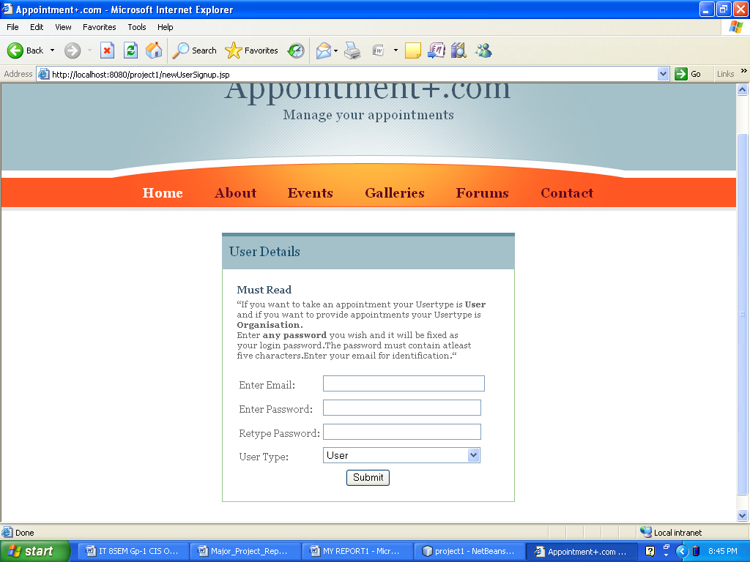

The client is required to fill in the valid email address and chosen password to create the account. This account will be used for further contacts and for providing any information to the client. The USERTYPE for client is “user” ,when the client clicks the SUBMIT button these entries will be entered in CUSTINFO TABLE. The client is provide a userID and the chosen password for future logins.

5.1.2 CLIENT LOGIN

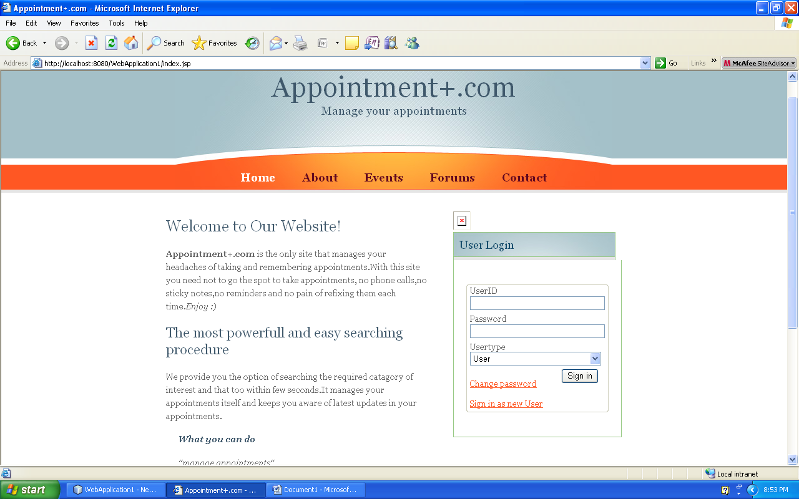

The client is required to login with provided ID, password and usertype i.e. “user”. When client clicks on SIGN IN button he is directed to the page showing options for the operations he can perform.

5.1.3 USERTASKS

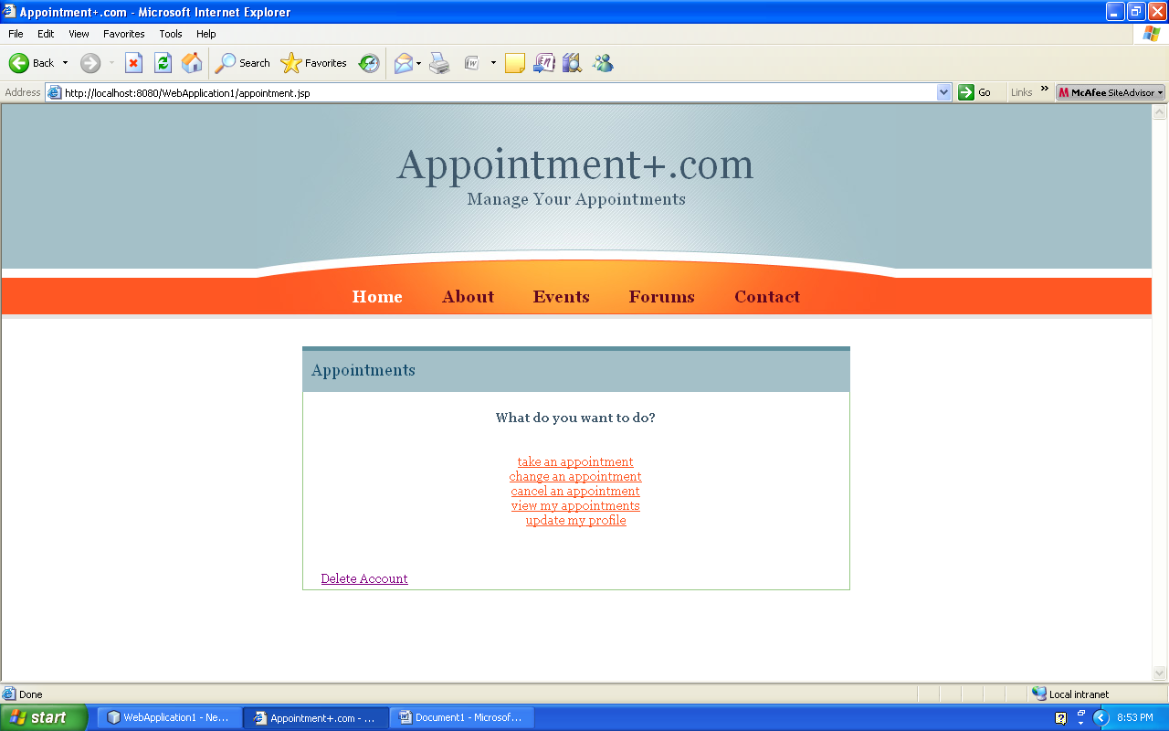

The client have to click the link for particular task. He can make, delete, view or change an appointment as required. He will be directed the corresponding page.

5.1.3.1 MAKING APPOINTMENT

The user here makes a **new appointment** selecting the specialist and appointment slot.

6.1.3.1.1 SELECT SPECIALIST GROUP

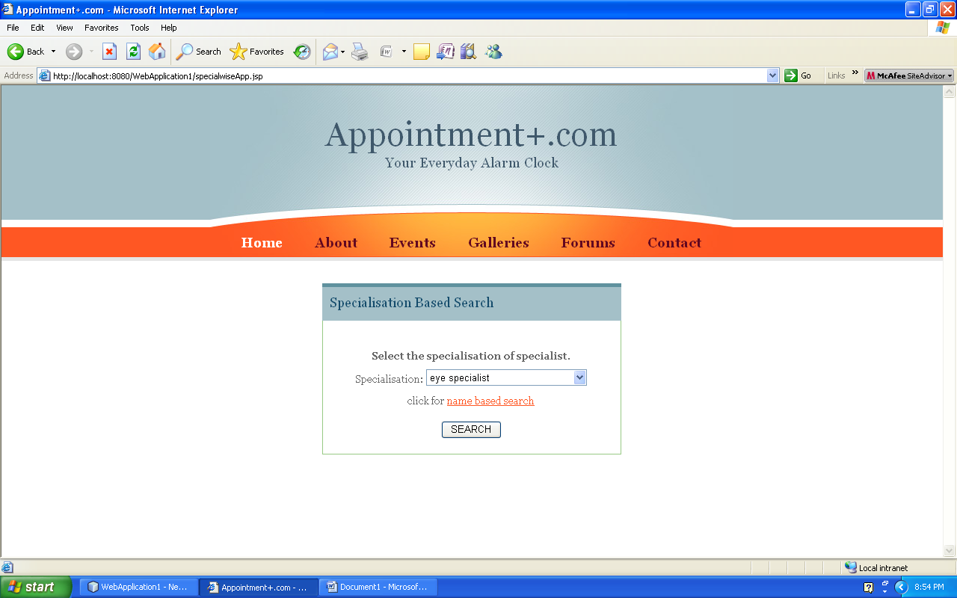

The client selects the specialist and clicks SEARCH button. The client can perform name based search also if he is sure about the specialist.

5.1.3.1.2 SELECT SPECIALIST

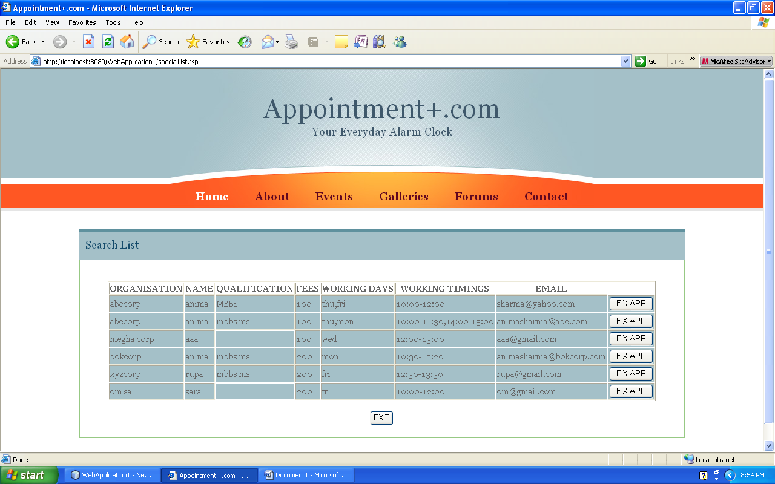

The client selects the particular **specialist** from the list of specialists shown or he can exit if he don’t want to take any appointment.

5.1.3.1.3 SELECT DATE

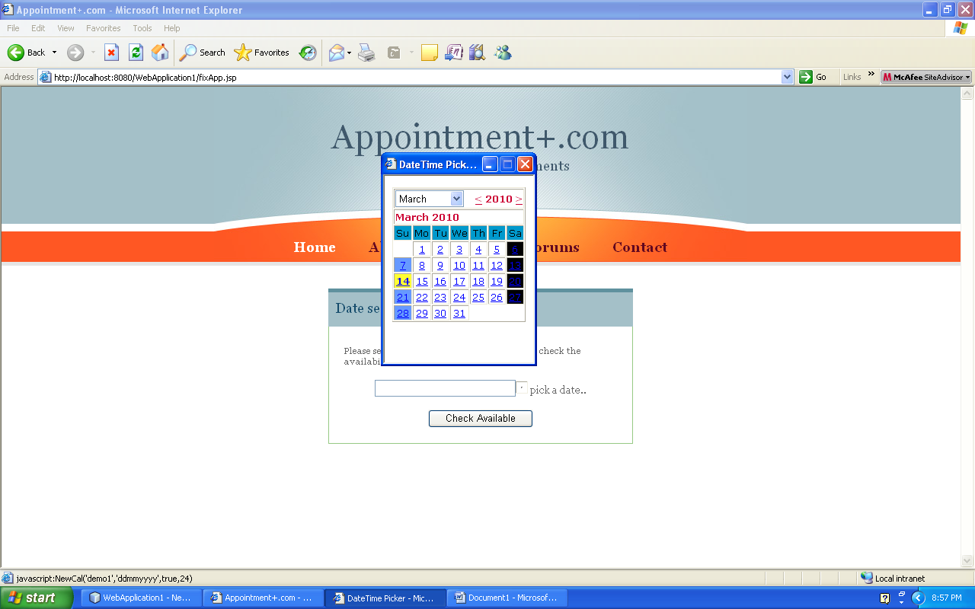

A **dynamic calendar** will be shown to the client for selecting date on which the client wants to take the appointment among the dates on which specialist works. The client selects the date and click CHECK AVAILABLE button to check the specialist’s free timings on that particular date.

If there are no free slots or if the specialist does not work on the day a message will be given to the client to select another date.

5.1.3.1.4 SELECT SLOT

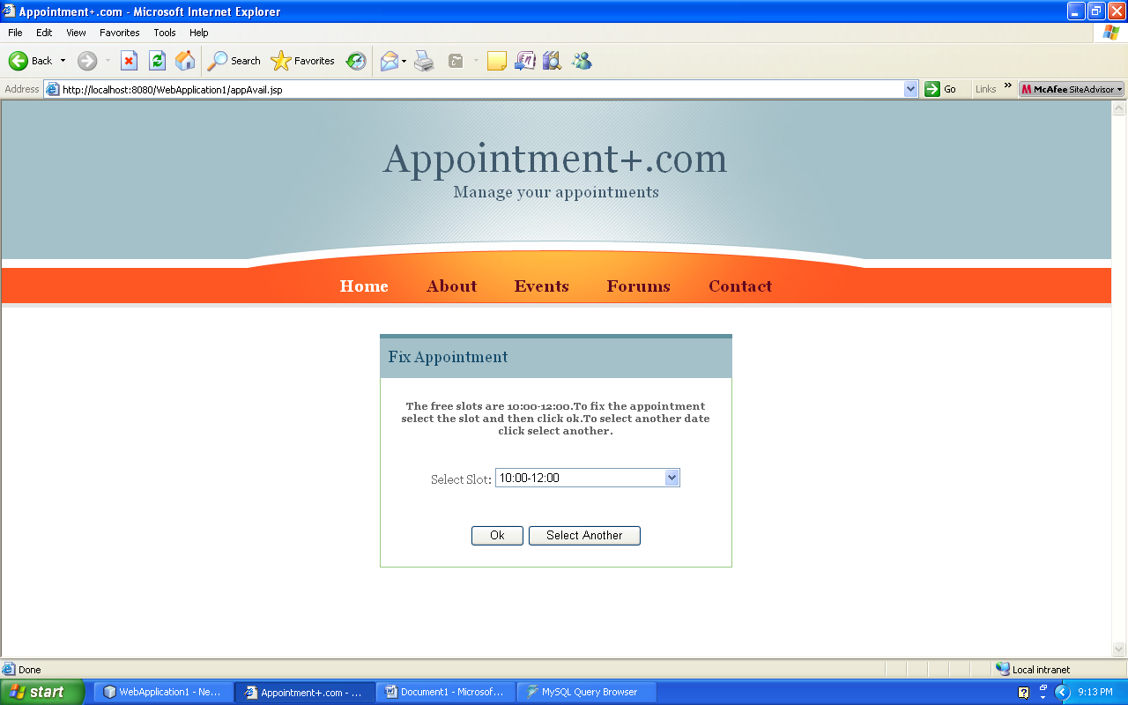

The slots that are available for booking in the date selected by client will be shown in a combo box from which the client can select one slot to **fix the appointment** by clicking on OK button or he can select another date by clicking on SELECT ANOTHER button.

If the appointment is available the client will be given a message and an email giving the details of the appointment.

5.1.3.2 DELETE APPOINTMENT

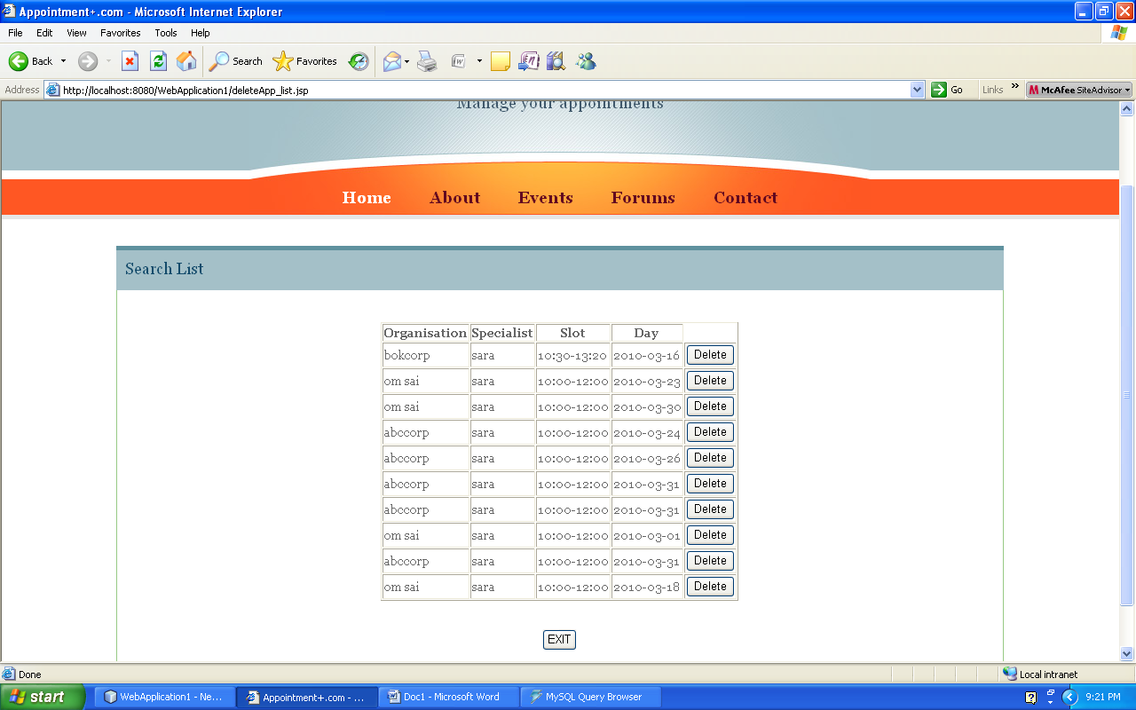

If the client clicks the link to **delete an appointment** he will be directed to the page containing the **active list** of appointments he may delete. The client has to click the DELETE button beside the appointment to delete it.

After successful deletion of the appointment a message will be given to the client.

If he don’t want to delete the appointment he can simply EXIT.

5.1.3.3 CHANGE APPOINTMENT

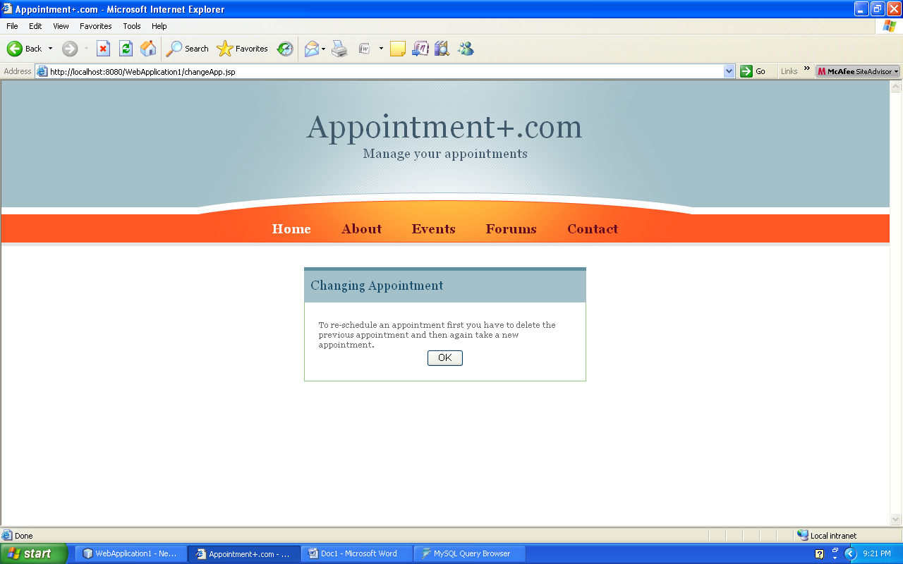

To change the appointment the client is required to delete the previous appointment and then again take a fresh appointment. The client will be informed about this process through a massage.

5.1.3.4 VIEW APPOINTMENTS

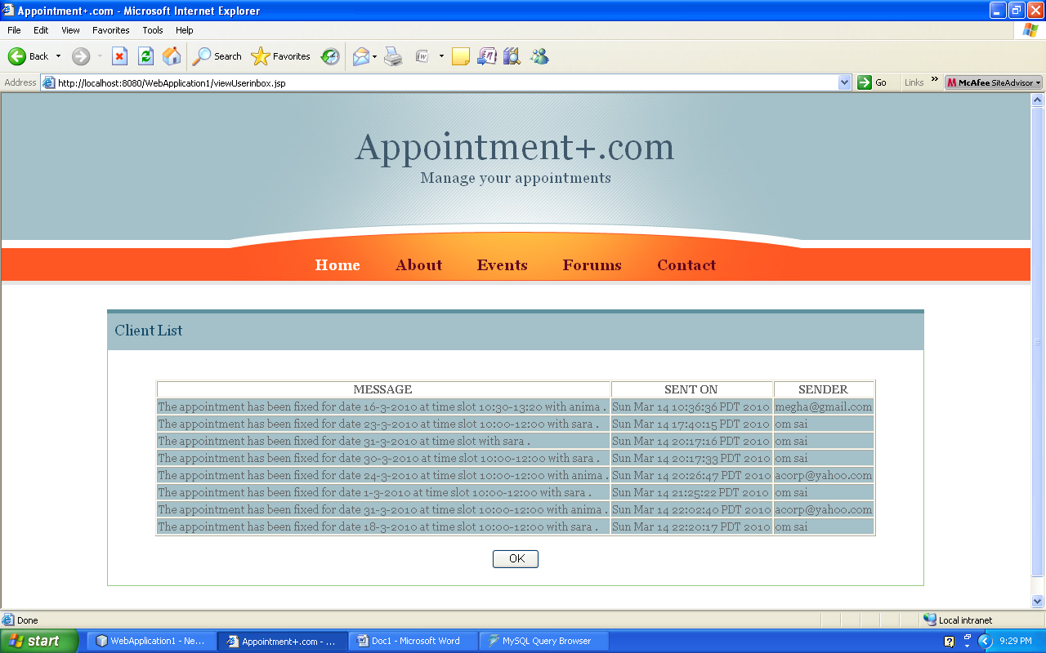

If the client clicks on view my appointments link then he will be directed to a page showing all the active appointments he is having. This page doesn’t allow any functions to perform.

5.1.3.5 UPDATE PROFILE

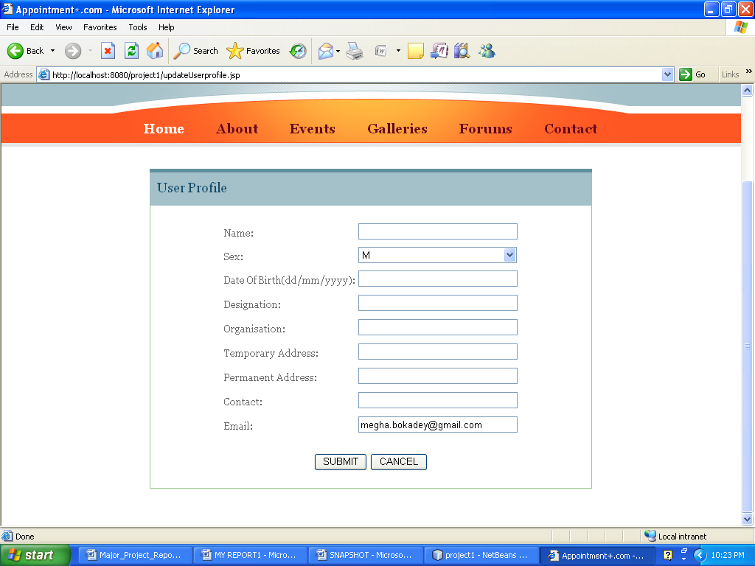

The client can maintain his profileif he is a **regular client** and wants the organization to know about him or if the organization demands so.

**5.2 ORGANISATION MODULE**

This module with all the functions the organization can perform to manage the appointments of its clients.

If a client visits the organization for taking the appointment instead of using the online facility then he can do so and thus the organization is equipped with the tools to fix the appointment itself.

5.2.1 CREATE ACCOUNT

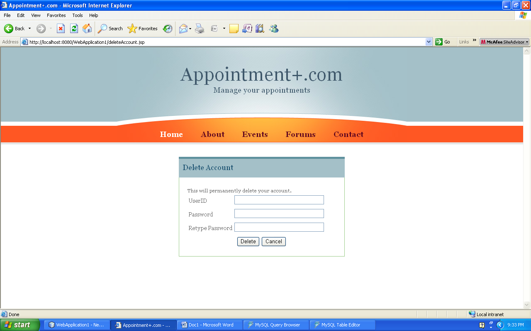

This page demands a valid email and chosen password of the organization. The USERTYPE here is **“Organization”**.

5.2.2 REGISTRATION

Before providing appointments the organization has to fill its details. These pages demand all such details.

5.2.2.1 ORGANISATION DETAILS

This page requires the details of the organization itself.

To fill the details the operator must click SUBMIT button.

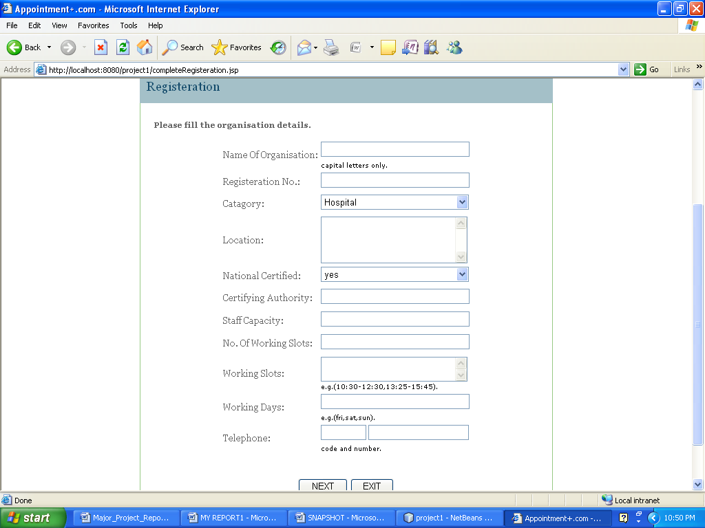

5.2.2.2 STAFF DETAILS

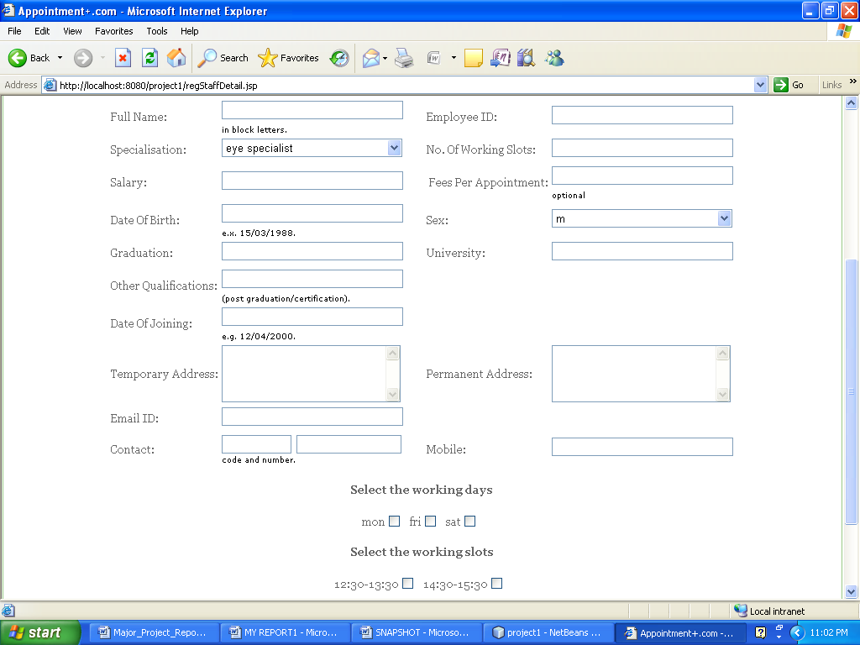

Here the details of all the employee working in the organization is entered respective to the organization.

When the operator clicks the NEXT button he can exit.

5.2.2.3 REPEAT ENTRY

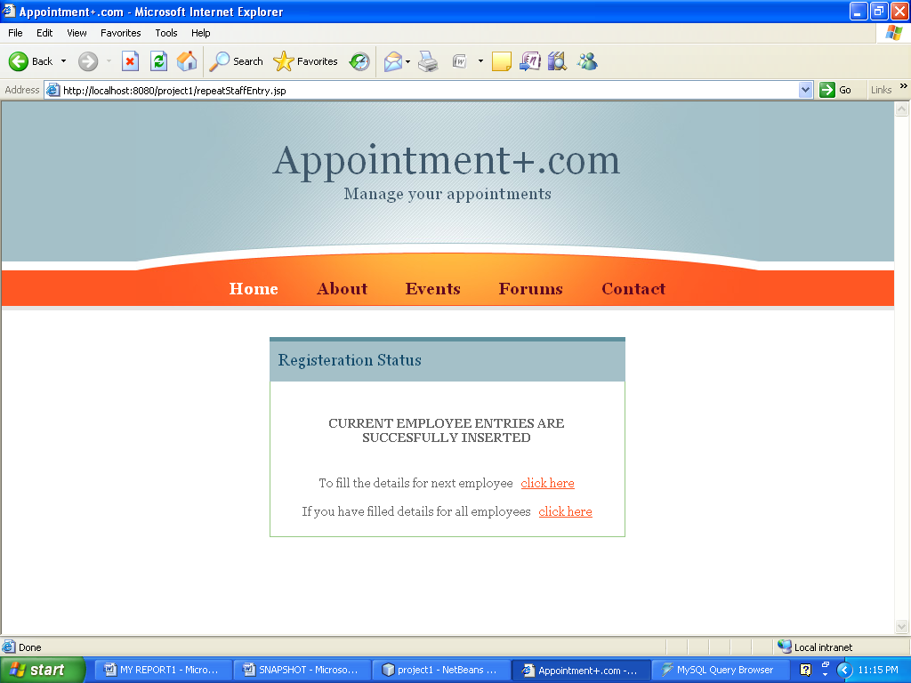

Here the operator can select to fill entries for next employee or can exit if he has already filled the entries for all staff.

5.2.3 ORGANISATION LOGIN



This is the first page of login where the ID and password of organization is required.

After this respective employee ID is required which is allocated by organization to its employees.The following page shows the process.

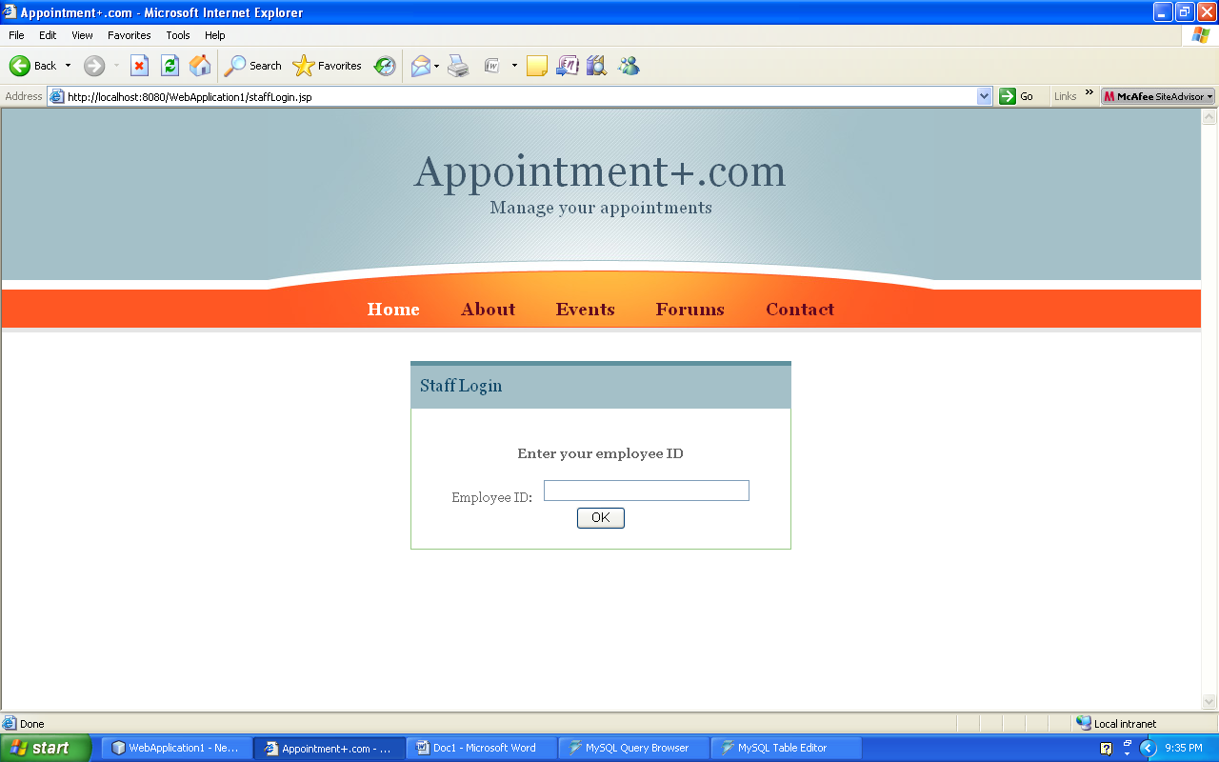

5.2.4 MANAGE APPOINTMENTS

The employee ID” HEAD “ allows to maintain the appointments.

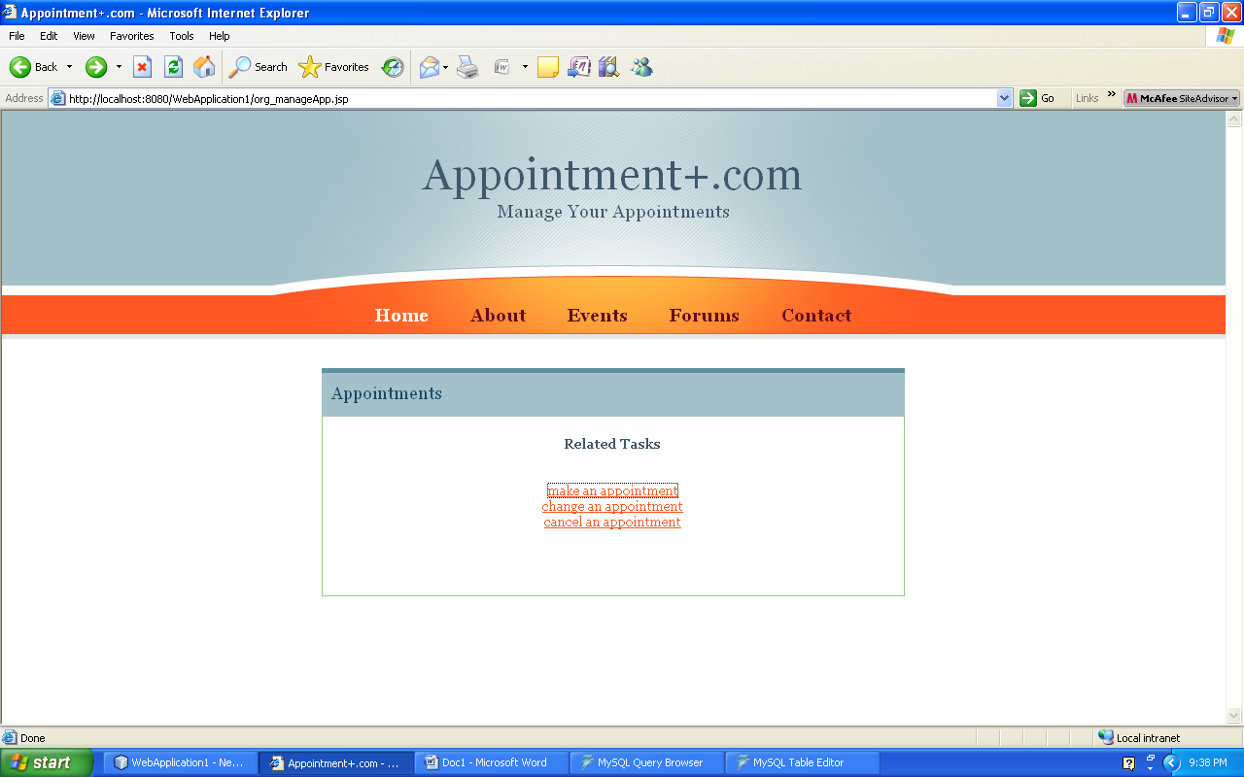

5.2.4.1 MAKE APPOINTMENT

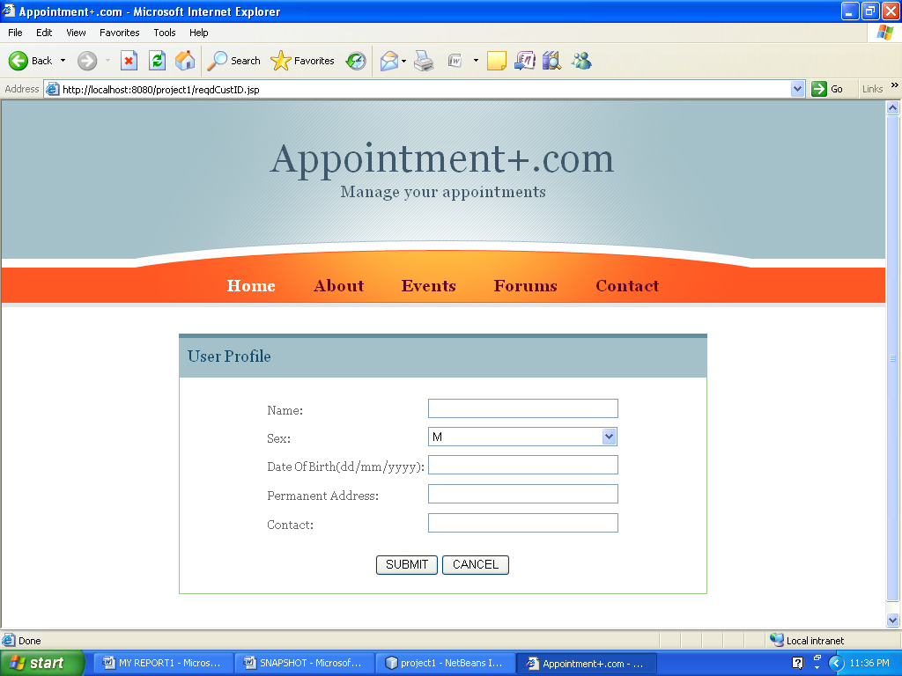

1.The process to make an appointment is same as that for clients accessing online. For fixing the appointment the details of the client is mandatory.

2.If the customer don’t want to fix the appointment the operator can exit the process.

3.A customerID will be allocated to the customer after he fixes the appointment. The client is required to remember this ID for unique identification.

5.2.4.2 DELETE APPOINTMENT

In this part of project the organizations are provided with the facility of deleting appointments of a particular employee.

5.2.4.2.1 DURATION OF DELETING APPOINTMENTS

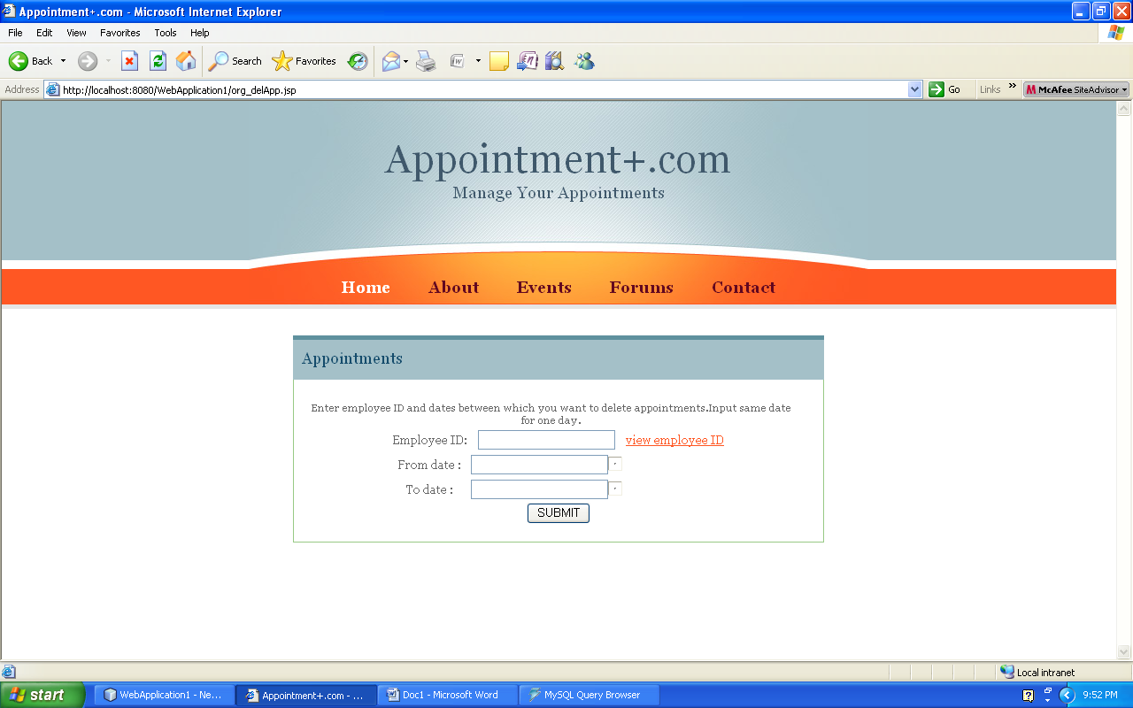

To delete an appointment the operator has to enter the corresponding employeeID and the duration (i.e. dates) during which the operator wants to delete the appointment.

5.2.4.2.2 LIST OF APPOINTMENTS

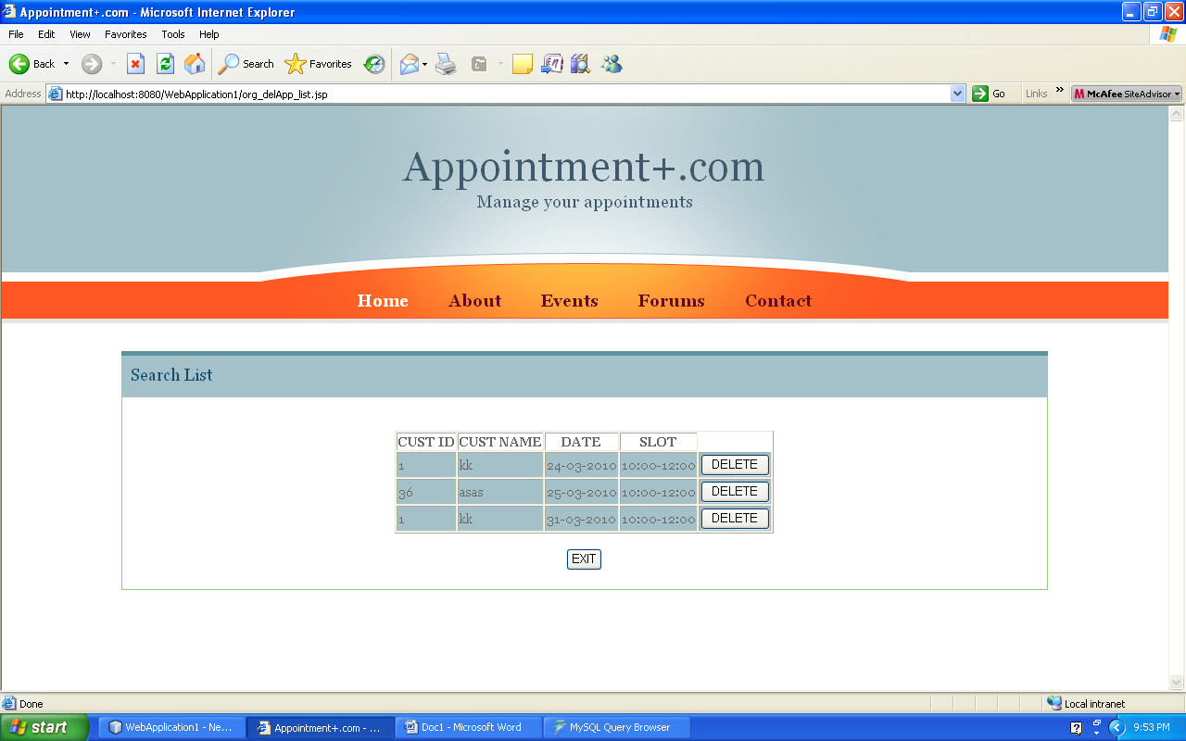

1. The list of all active appointments of the employee during the dates entered are shown. To delete the appointment the operator is required to click the DELETE button provided in each row.

2. If the operator don’t want to delete he can exit the process.

5.2.4.3 CHANGE APPOINTMENTS

To change the appointment the organization and then take a fresh appointment.

6.2.5 UPDATE RECORDS

The organization are provided with the facility to update the organization records and adding any new staff as well.

**5.3 COMMON MODULES**

There are some functions which can be performed by both the organization and clients.

5.3.1 CHANGE PASSWORD

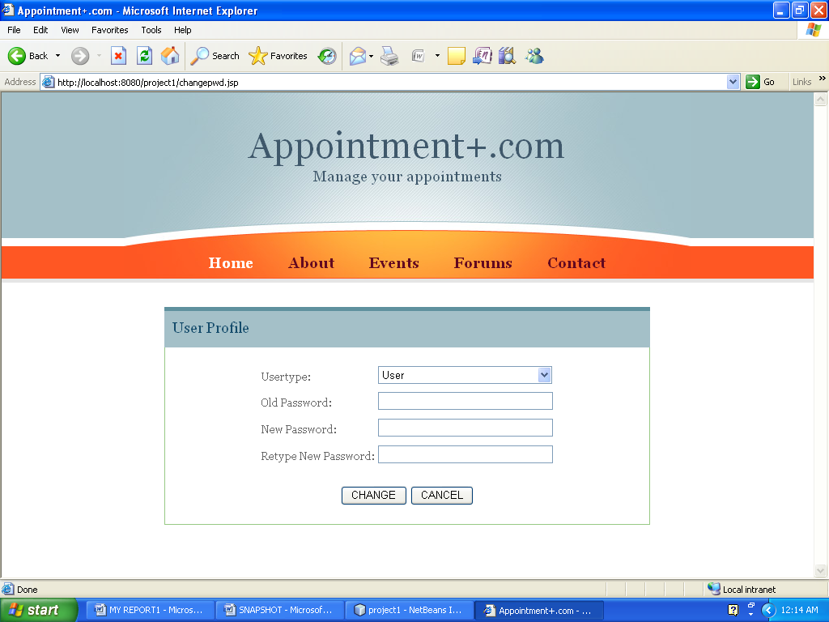

This facility is provided to change the password of an account holder.

5.3.2 DELETE ACCOUNT

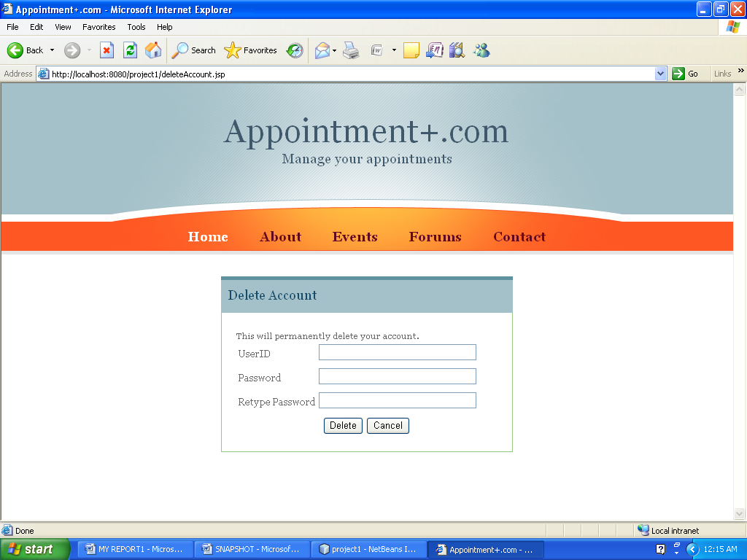

This process permanently deletes the account of an account holder.

**5.4 ADMINISTRATOR MODULE**

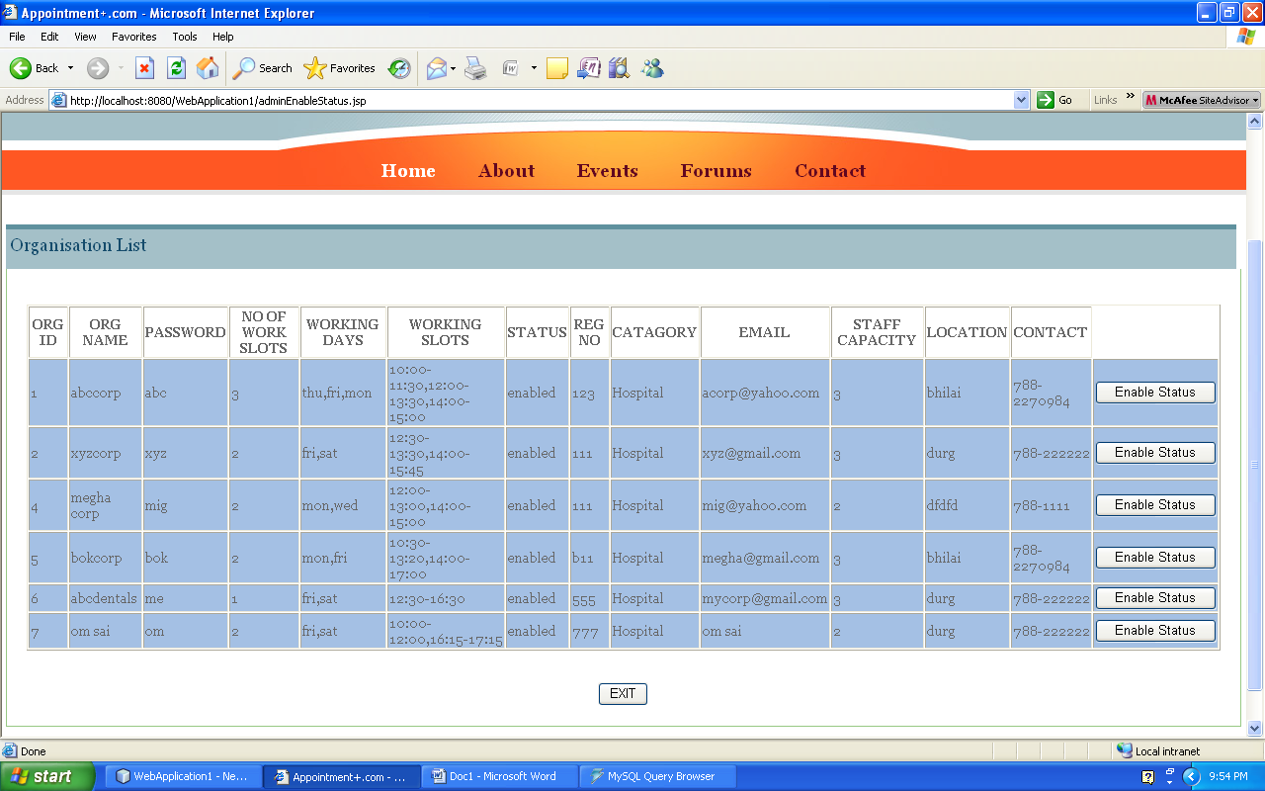

1. This module enables the status of an organization.

2. The validity of the organization is an important issue while before allowing them to provide appointments.

3. Hence the work of administrator is to check the documents related with the license provided to an organization by the Government, thereby verifying them valid.

4. After certifying themselves the organizations are allowed to provide appointments.

**TESTING**

**TESTING**

**6.1 Testing Approach :**

In this project, among the above mentioned, following testing is performed:

* Functional testing (includes both white and black box testing)
* Compatibility testing.
* Unit testing.
* Integrated testing.

Unit and Compatibility testing involves functional testing as the supported testing, as functional testing is providing the both valid and erroneous input and unit testing treats each interface as modules and test it with both types of valid and invalid inputs.

Whereas integrated testing is done keeping in mind the combination of different modules, and checking the valid transactions between any two pages.

**FUNCTIONAL TESTING**

* Validating an application or Web site conforms to its specifications and correctly performs all its required functions.
* This entails a series of tests which perform a feature by feature validation of behavior, using a wide range of normal and erroneous input data.
* This can involve testing of the product's user interface, APIs, database management, security, installation, networking, etc. testing can be performed on an automated or manual basis using black box or white box methodologies.

**COMPATIBILITY TESTING**

* Testing to ensure compatibility of an application or Web site with different browsers, Operating Systems, and hardware platforms.
* Compatibility testing can be performed manually or can be driven by an automated functional or regression test suite.

**UNIT TESTING**

* Functional and reliability testing in an Engineering environment.
* Producing tests for the behavior of components of a product to ensure their correct behavior prior to system integration.

**INTEGRATION TESTING**

* Testing in which modules are combined and tested as a group.
* Modules are typically code modules, individual applications, client and server applications on a network, etc.
* Integration Testing follows unit testing and precedes system testing.

**CONCLUSION & FUTURE SCOPE**

**CONCLUSION & SCOPE OF FUTUREWORK**

**7.1 CONCLUSION**

Here upon the project has been developed with the intention to automate the APPOINTMENT MANAGEMENT SYSTEM. The concept of developing "APPOINTMENT+.COM" is to reduce the time consumption for visiting the organization and to provide the users the information about various organizations and specialists.

With the conclusion of our project, we hope that our work will be proved helpful and will help organizations and clients to conduct appointment related operations successfully, effectively with an ease.

**7.2 FUTURE SCOPE**

1. An online advance payment before fixing an appointment is yet to be implemented.
2. Sharing the same place by more than one specialist is complex and yet to be implemented.

**BIBLIOGRAPHY AND REFERENCES**

**References & Bibliography**

* + Subramanium Allmaraju, Professional JSP…..J2EE 1.3 edition
  + James Goodwill, Pure Java Server Pages
  + Roger S.Pressman “Software Engineering A Practitioner’s Approach” ,6th Edition Tata McGraw Hill International Edition.
  + Silberschatz, Korth, Sudarshan , “Database System Concepts” , fifth edition
  + <http://en.wikipedia.org/wiki/JavaServer_Pages>.
  + <http://javasu.sun.com/javaee/6/docs/api/javax/servlet/httppackage-summary.html>
  + <http://en.wikipedia.org/wiki/Java_servlet>